

SCM

**ITEC316 Software Engineering**

**Homework Assignment**

**S. Eser Ozvataf  
100178**

# Software Configuration Management

#### What Is Software Configuration Management?

For a software project, SCM (software configuration management) is the mechanism for taking control and management of development. It provides an ability to track and control changes during the base production and later on maintenance and evolution steps.  
  
There are lots of “formal” descriptions to define SCM (software configuration management). According to Anne Mette Jonassen Hass (the author of Configuration Management Principles and Practice), “*Conﬁguration management is unique identiﬁcation, controlled storage, change control, and status reporting of selected intermediate work products, product components, and products during the life of a system*”.

#### Why SCM Is Required?

The need for a SCM is mostly felt when there are many developers are assigned in the same project, or, there are many versions of the same project. SCM acts the backbone for the scenarios where bug fixing should happen on multiple production systems or multiple versions and the enhancements also must be continued on the main code base.

#### What Solutions SCM Offers?

SCM helps to reduce these problems by coordinating the work products of the many different people who work on a common project.

1. **Simultaneous Update**  
   When two or more programmers work separately on the same project, the last one to make the changes can easily destroy the other’s work. SCM prevents this kind of conflicts by version management.
2. **Shared Code**  
   Often, when a bug is fixed in code shared by several programmers, some of them are not notified. SCM offers issue tracking tools to share tasks and work to programmers.
3. **Versions**  
   Most large programs are developed in evolutionary releases. With one release in customer use, another in test, and a third in development, bug fixes must be propagated between them. If found by a customer, for example, a bug should be fixed in all later versions.  
     
   Similarly, if a bug is found in a development release, it should be fixed in all those prior versions that contained it. In larger systems with several simultaneous active releases and many programmers working on bug fixes and enhancements, conflicts and confusion are likely.  
   Again, by using version control systems of SCM, project can be reverted to any previous version, branches can be created or be merged.
4. **Build Management**  
   Software developers do some tasks every time they has to publish their work to test or production environments. It may compiling the code, packaging the binaries with libraries, resource files and installers, running unit tests, building documentation or all of them. For continuous integration it take much time to complete these tasks manually.  
     
   SCM offers build management to complete such tasks in automation and delivers the final package after executing of batch processes.

#### Real Life Scenarios and Tools

SCM is neither a new hype nor a traditional thing. It depends on how it will be implemented and in most cases implementation up to the tools which are going to picked.

Therefore it is better to examine the “real scenario” is on the use to find out how things work together.  
  
Goldsoft Trading Ltd. (<http://www.goldsofttrading.com/>) uses a SCM, it is taken as a sample below.

##### Homepage:

In the sample, homepage enables easy access to SCM features with links.  
  
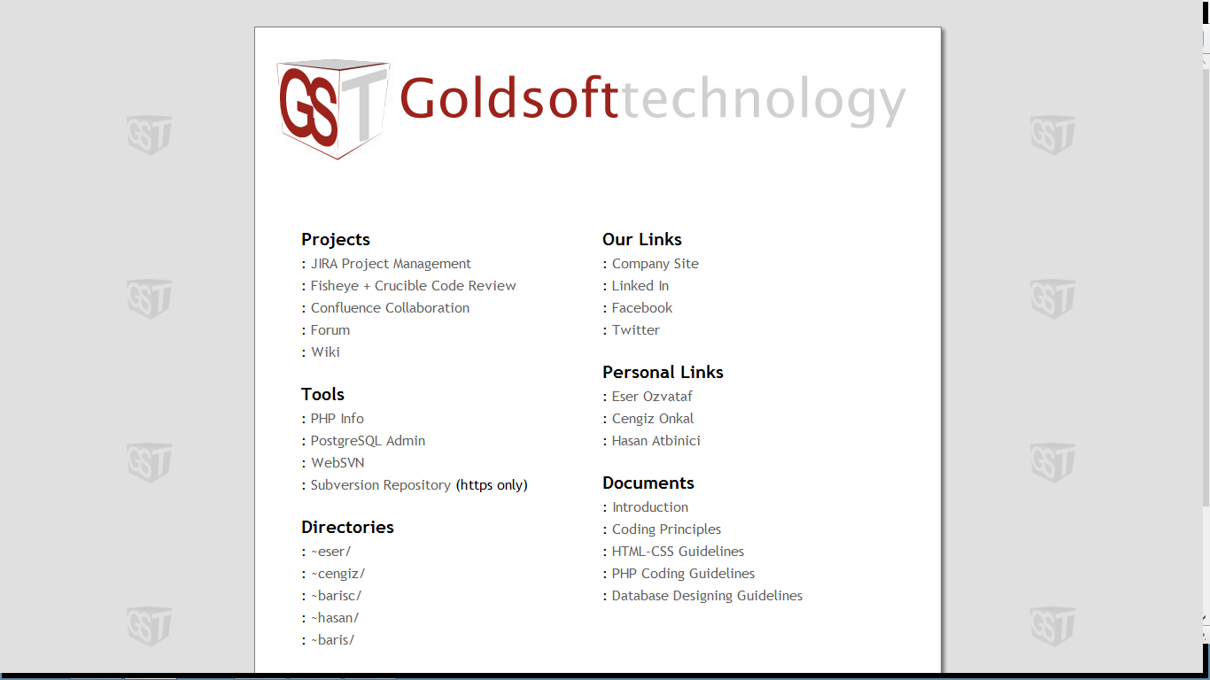

##### JIRA Project Management / Issue Tracking:

JIRA is a proprietary issue tracking product, developed by Atlassian. Commonly used for bug tracking, issue tracking and project management. Goldsoft uses JIRA with its famous add-on GreenHopper, which enables extreme programming features of this tool.

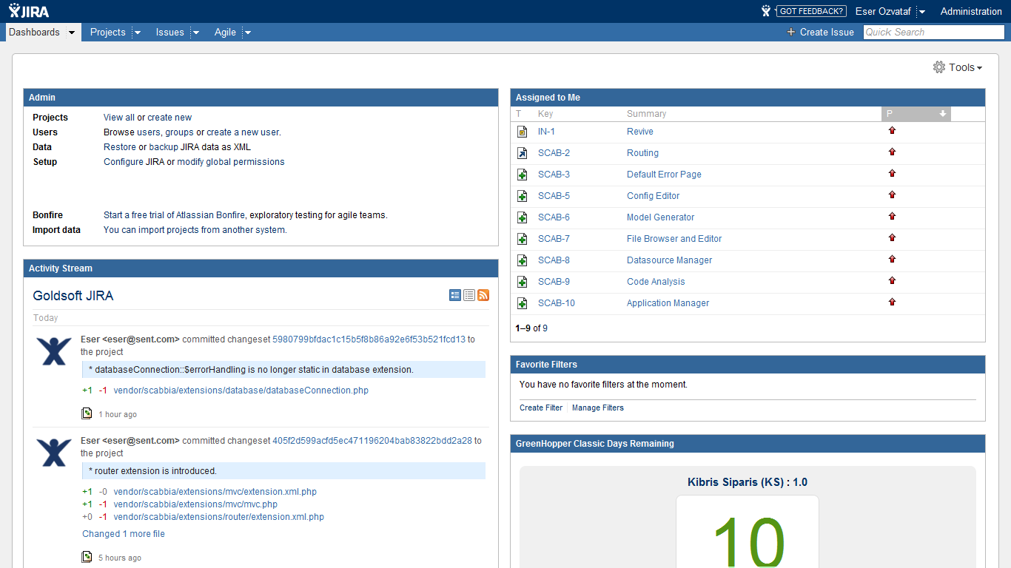

jira homepage

JIRA provides assignment of issues to proper developer who is working on project. Also has time-tracking features and reports related with employee performances.

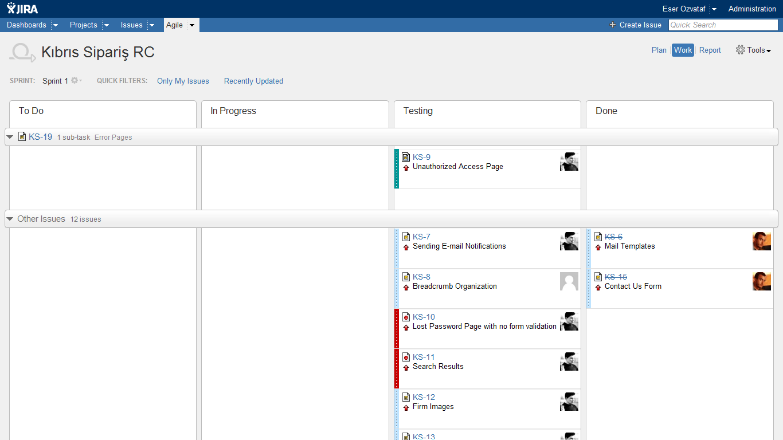

sprints

By using GreenHopper (an add-on) JIRA becomes powerful with SCRUM development method features. Project Manager can start a sprint, and track all issues on the sprint.  
Also entire workflow can be designed and altered by using its editor.

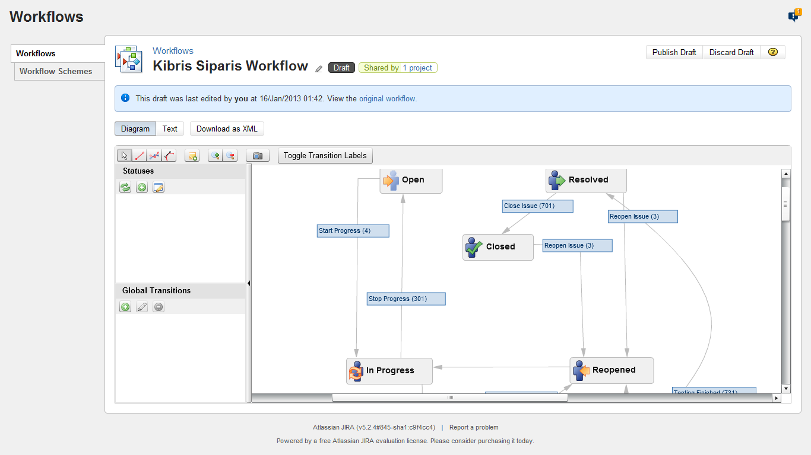 workflow designer

##### Fisheye, Crucible and Subversion (Source Code Control Systems):

Other Atlassian products which Goldsoft uses are Fisheye and Crucible. These two products works together on the same web frontend and enabled “code reviewing”.

The importance of Quality Assurance needs some testing phases like “code reviewing”. In a software team, code reviewing is the process of controlling each other’s code to find some defects or errors. Therefore the written code is also tested by other developers.

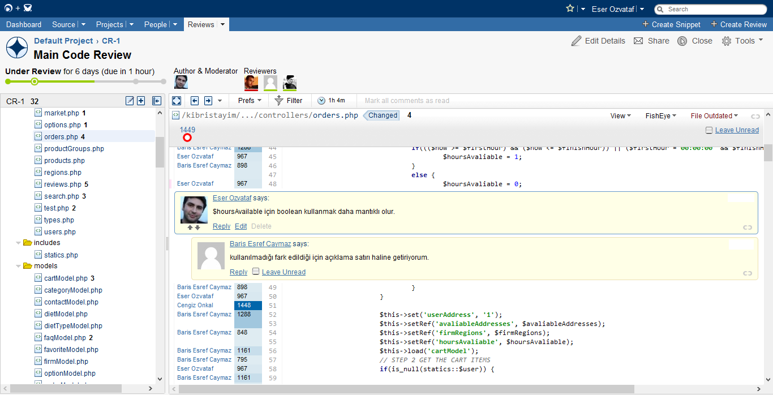

When a developer found a defect, or has a suggestion on code he/she just add his/her comment on the related line so the other developer can fix or defend his/her marked code.

Also subversion provides a backbone for both version controlling and the host for these products. Subversion is a background service to maintain code versions, it is accessible with 3rd party tools like TortoiseSVN.  
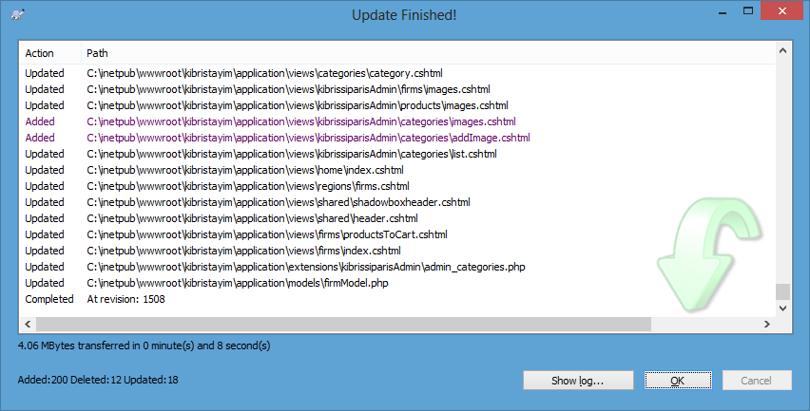

TortoiseSVN also has management features such as creating/merging branches and tags, making comparisons and reverting features in source control repository.  
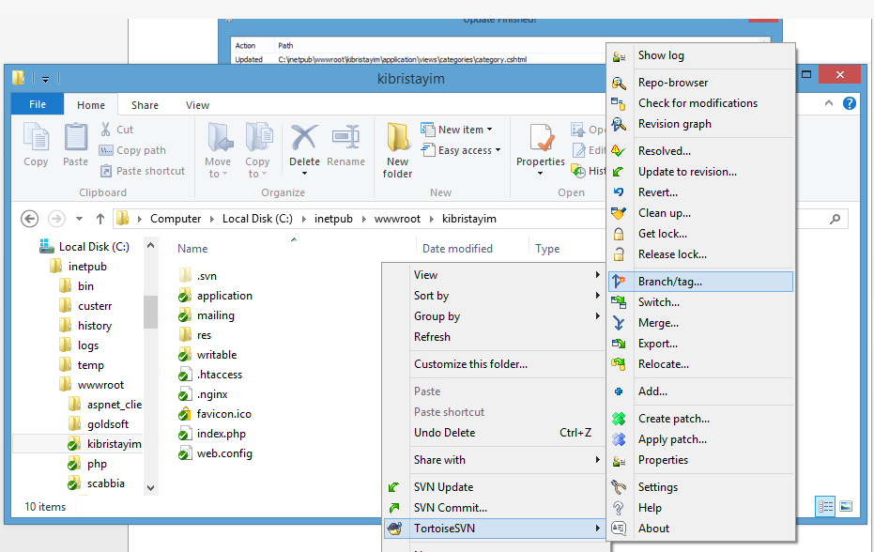

#### References

[1] Configuration Management Principles and Practice - Anne Mette Jonassen Hass  
(ISBN 978-0321117663)  
<http://www.amazon.com/Configuration-Management-Principles-Practice-Jonassen/dp/0321117662>

[2] Managing the Software Process - Watts S. Humphrey  
(ISBN 978-0201180954)  
<http://www.amazon.com/Managing-Software-Process-Watts-Humphrey/dp/0201180952>

[3] Software configuration management, Wikipedia  
<http://en.wikipedia.org/wiki/Software_configuration_management>